Overview
Overview
Unit: 5  Square Root | 2(A) graph the functions f(x)=√x, f(x)=1/x, f(x)=x3, f(x)= 3√x, f(x)=bx, f(x)=|x|, and f(x)=logb (x) where b is 2, 10, and e, and, when applicable, analyze the key attributes such as domain, range, intercepts, symmetries, asymptotic behavior, and maximum and minimum given an interval
 | 2(C) describe and analyze the relationship between a function and its inverse (quadratic and square root, logarithmic and exponential), including the restriction(s) on domain, which will restrict its range
4(C) determine the effect on the graph of f(x) = √x when f(x) is replaced by af(x), f(x) + d, f(bx), and f(x - c) for specific
positive and negative values of a, b, c, and d;
 | 4(F) solve quadratic and square root equations;
 | 7(H) solve equations involving rational exponents;
 | 4(G) identify extraneous solutions of square root equations
 | 7(I) write the domain and range of a function in interval notation, inequalities, and set notation.
Learning Target | I can simplify square roots including those with variables and rationalize denominators. | I can graph f(x) = √  x and  identify key attributes: domain, range, intercepts, and end behavIor.  (TEKS 2A, 7I) | I can identify transformations of  f(x) = √x and determine the effect of a, b, c, d on the graph.  (TEKS 4C) | I can solve square root equations  with a radical on one side and  a constant on the other. Check  for extraneous solutions. (TEKS  4F, 4G) | I can solve square root equations  with radicals and/or variables on  both sides. Identify extraneous  solutions. (TEKS 4F, 4G)
Do Now
Mini Lesson
Work Time
Evidence of Learning | Solve: | Evidence of Learning Day 2 | Evidence of Learning Day 3 | Evidence of Learning Day 4 | Evidence of Learning Day 5
Learning Target | I can solve a square root equation with a radical on one side and a constant on the other.  ***note - include coefficient on some  ***check for extraneous  ***note - include ½ exponent | I can solve a square root equation with a radical and a variable on both sides.  ***note - radicals on both sides and with a radical on one side and variable on the other. | I can analyze inverse relation-  ships between quadratic and  square root functions, including  domain restrictions. (TEKS 2C) | Review Day: I can demonstrate  mastery of all unit concepts. | Test.
Do Now
Mini Lesson
Work Time
Evidence of Learning | Evidence of Learning Day 6  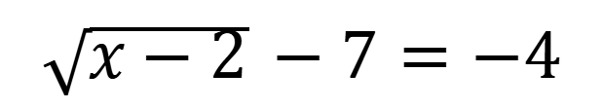 | Evidence of Learning Day 7 | Evidence of Learning Day 8 | Evidence of Learning Day 9 | Evidence of Learning Day 10

Key points of Unit
Graph and analyze the parent function f(x) = √x, identifying domain, range, intercepts, and end behavior.

Apply transformations to square root functions using parameters a, b, c, and d, and determine their effect on the graph.

Solve square root equations algebraically, checking for extraneous solutions.

Understand the inverse relationship between quadratic and square root functions, including necessary domain restrictions.

Simplify radical expressions and rationalize denominators.

Advanced and onlevel classes move at different paces.

EOV Day 1
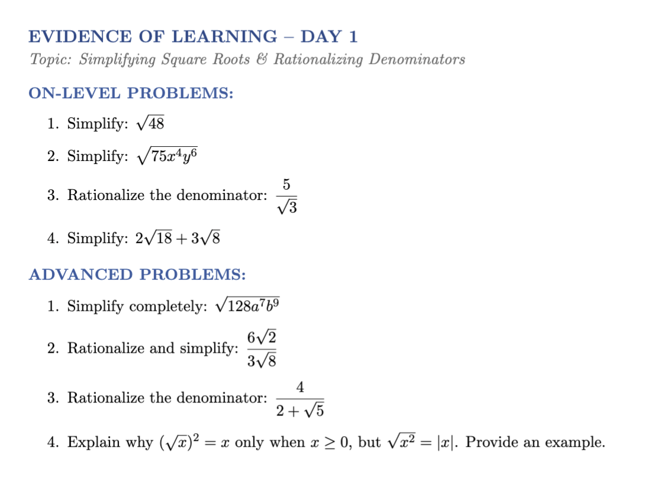

EOV Day 2
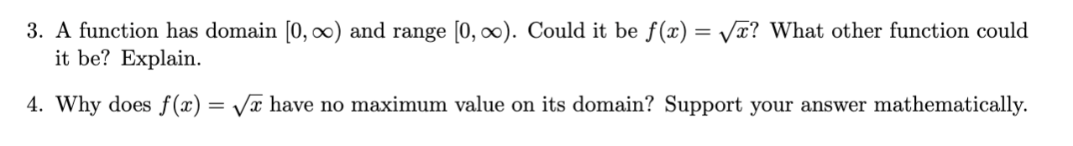
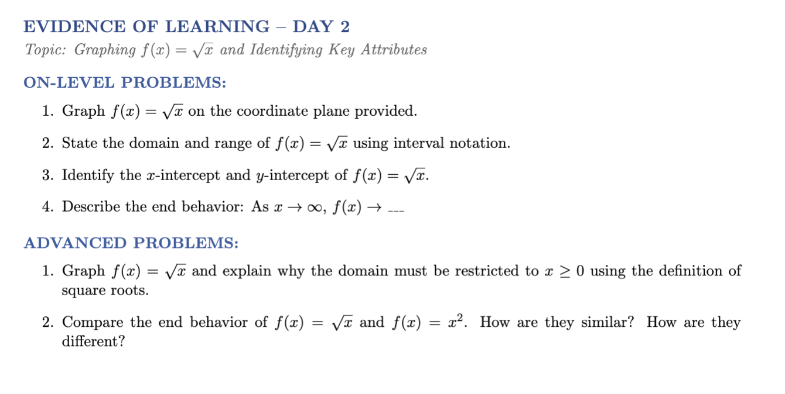

EOV Day 3
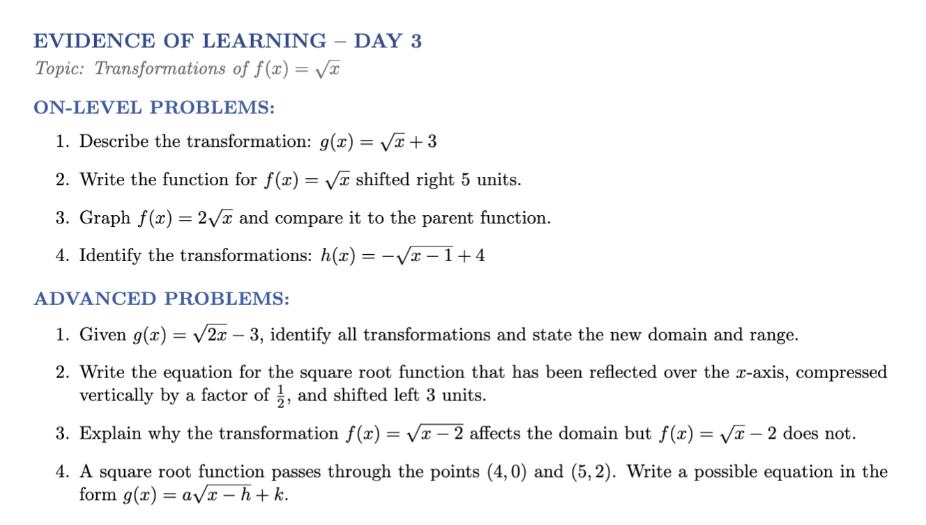

EOV Day 4
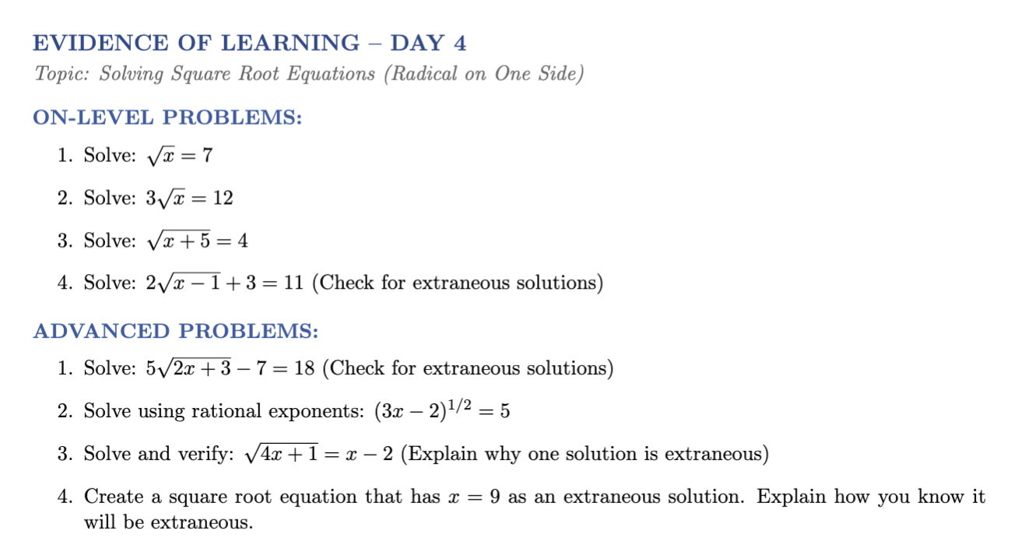

EOV Day 5
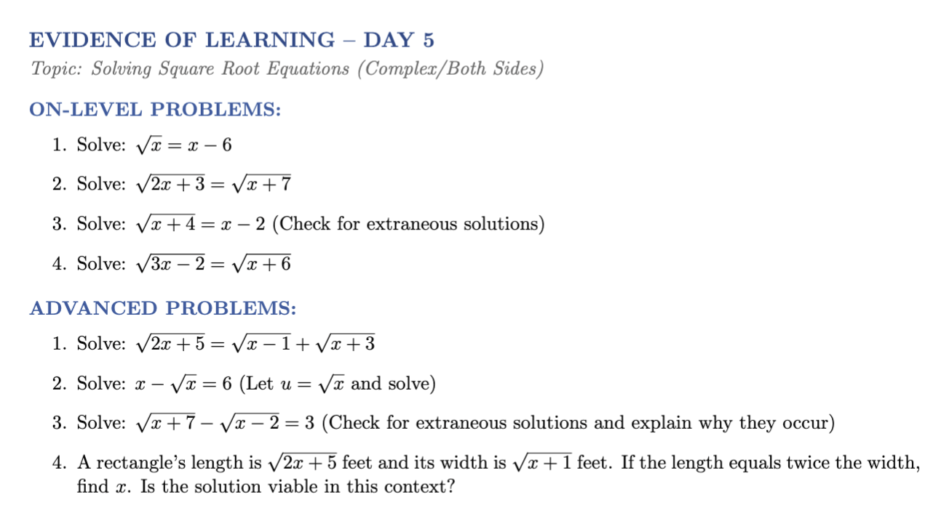

EOV Day 6
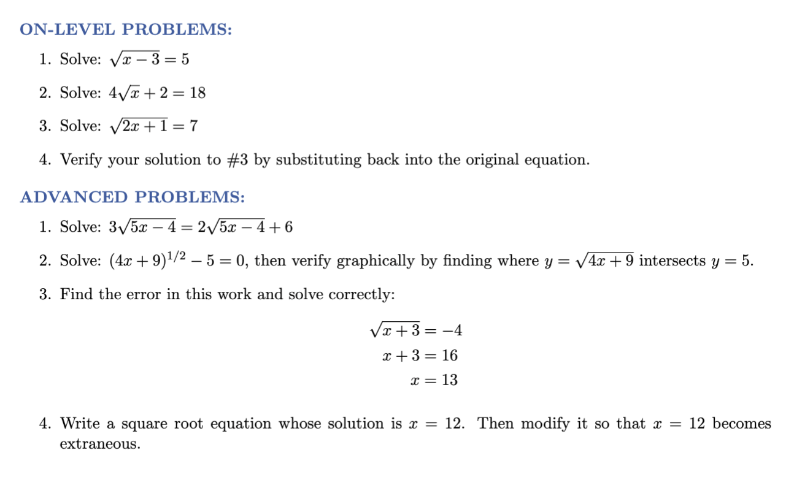

EOV Day 7
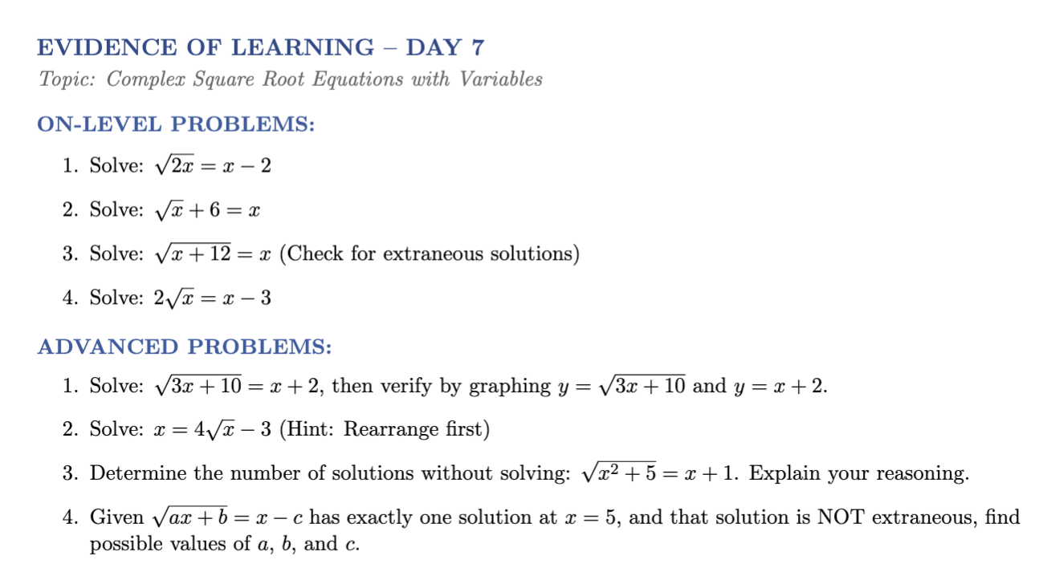

EOV Day 8
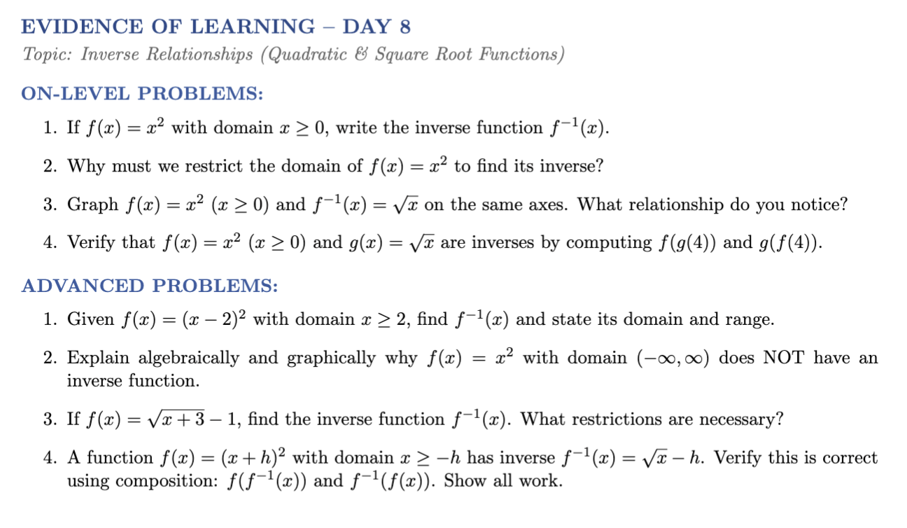

EOV Day 9
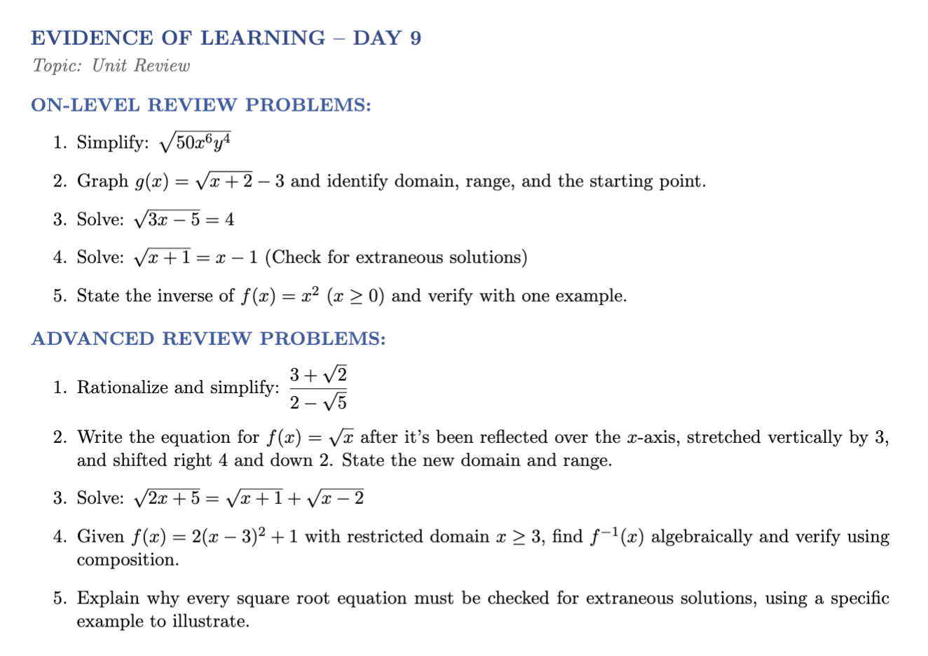

EOV Day 10

